EECE 340 Project Module 3 Report

Abdullatif Itani 202203750

Charbel Toumieh 202218744

3- Quantization:

This code is designed to perform image quantization, which is a technique used to reduce the number of distinct colors used to represent an image. We first load the image then convert it to double-precision format. We then use the function we created to quantize the image. The function takes three inputs: the original image, a threshold value, and a set of quantization levels. The function iterates through each pixel of the input image and performs the quantization based on the threshold and levels provided for each pixel individually. The resulting quantized image is then displayed. Using the threshold and level values given, the image was converted into black and white.

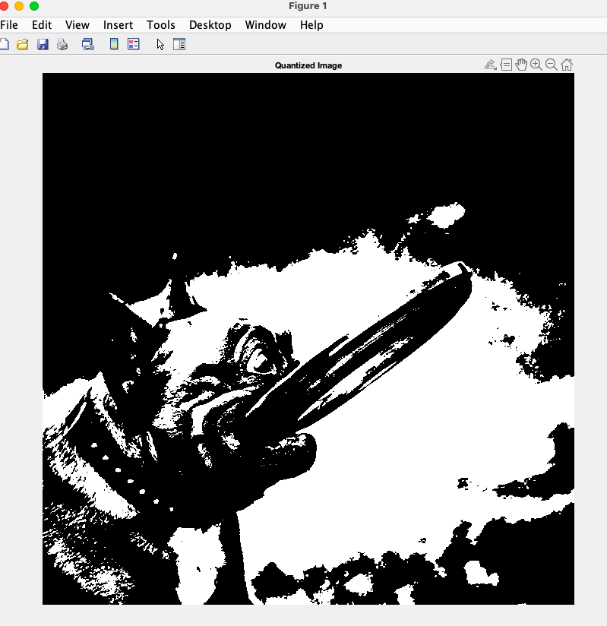

3.1- Uniform Quantization:

This code performs uniform quantization on the image and calculates the mean squared error (MSE) of the quantization. First we load the image and divide the range of pixel intensities (0 to 255) into 8 equal intervals to create the threshold(thr) array. The center of each interval is chosen as the quantization level using the 'diff' function to calculate the interval size. Then the 'quan' function is used to quantize the image using the thr and lvl values. Afterwards the MSE of the quantization is calculated by subtracting the quantized image from the original image, squaring the difference, and then summing over all the pixels. The result is divided by the total number of pixels to get the MSE. The MSE value, which is equal to 83.3545 provides a measure of how different the quantized image is from the original image.

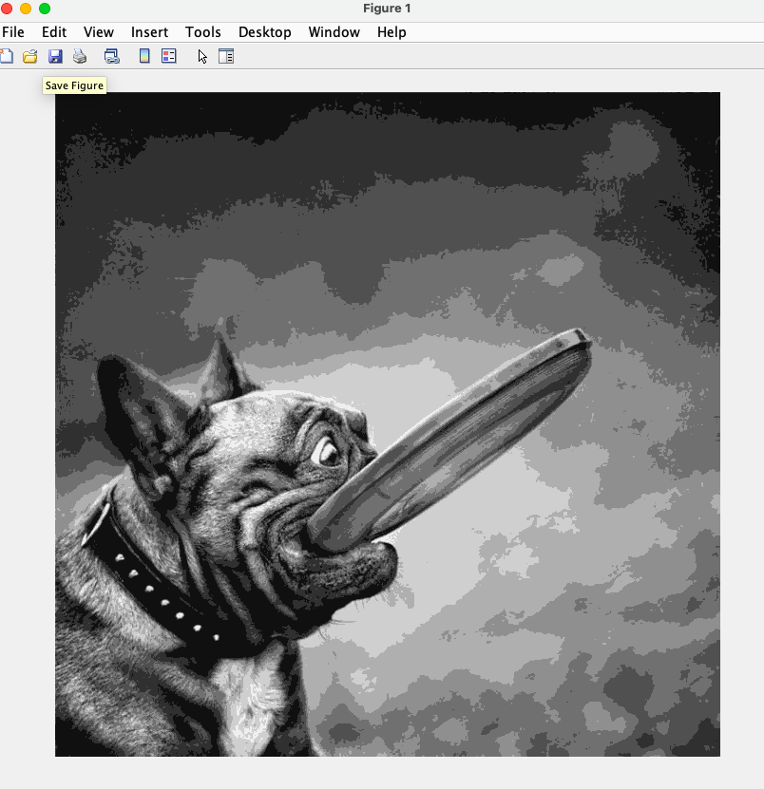

3.2- Selective Quantization

This code performs selective quantization on the image and calculates the mean squared error (MSE) of the quantization. The selective quantization technique divides the range of pixel values into several intervals based on their percentiles. The ‘prctile’ function computes the percentiles of the pixel values. The quantized values are chosen by selecting the center of each interval using the ‘diff’ function. The mean squared error (MSE) between the original and quantized images, which is 110.0305, is also calculated using the way described before.

